A glimpse at the history of the microscope
Comprehension task: Read and answer in COMPLETE sentences on a separate sheet of paper.
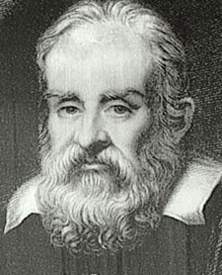
Compound microscopes are made up of several lenses that magnify an object that cannot usually be seen with the naked eye. It is called a compound microscope because it has more than one lens. Galileo Galilei is credited with inventing one of the first compound microscopes in the year 1625.
1. Why is it called a compound microscope?
2. Who invented the first compound microscope?
3. When did Galileo invent the first microscope?
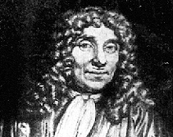
Von Leeuwenhoek's Early Microscope
Leeuwenhoek's early microscope was called a simple microscope because it only used one lens. This kind of simple microscope was much like a magnifying glass that you might use to look at an insect or picture. This way of looking at things is limited and is what enticed people to create the compound microscope, which uses more lenses. The word Microscope is the combination of two words; "micro" meaning small and "scope" meaning view.
4. What did Leeuwenhoek invent?
5. How many lenses did his invention use?
6. Why did people choose to improve his design by adding more lenses?
7. What does ‘micro’ mean?
8. What does ‘scope’ mean?
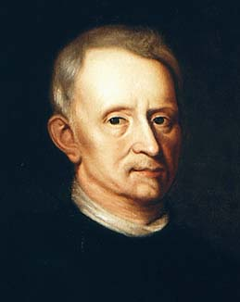
Leeuwenhoek was not the first person to build a microscope, but the microscopes that he did build were the best ones for that time period. Leeuwenhoek was the first person to describe bacteria and helped to prove the theory of blood circulation. He gained much of his inspiration from reading Robert Hooke's book, Micrographia. Hooke was the person who discovered and named cells.
9. Was Leeuwenhoek the first person to build a microscope?
10. Where did Leeuwenhoek get a lot of inspiration for his work?
11. Who discovered and named cells?

